1] **grep ‘wordtobesearched’ ‘filename’ :**

This command is used to find the word inside the file or coresponding file

Eg- grep ‘Linux’ f3

Its shows to find word Linux inside f3 file as in below screenshot

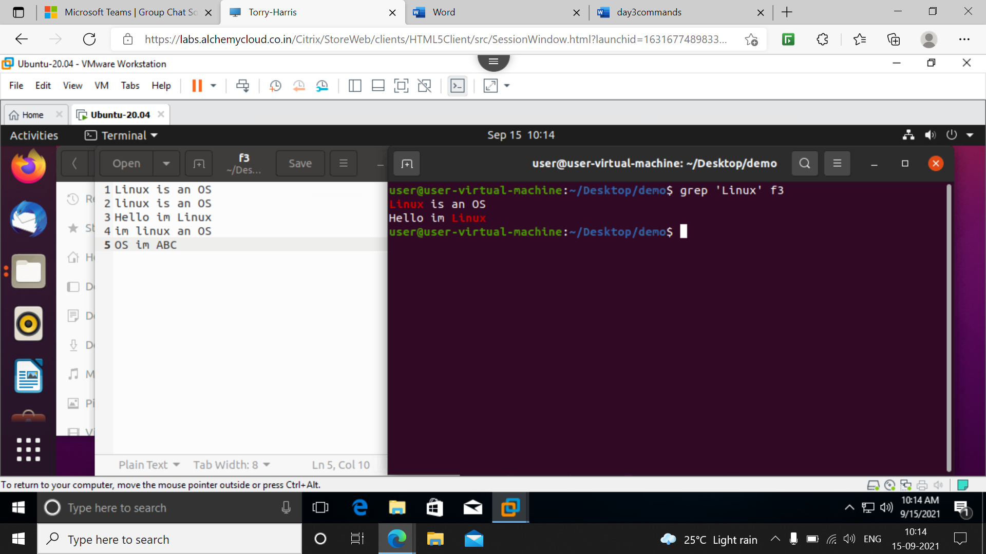

**2] grey ‘linux’ f3**

It will find the word linux inside f3 file (it is case sensetive so two different commands are used)

**3] grey -I ‘linux’ f3**

It ignore the cases and find the word linux in our file

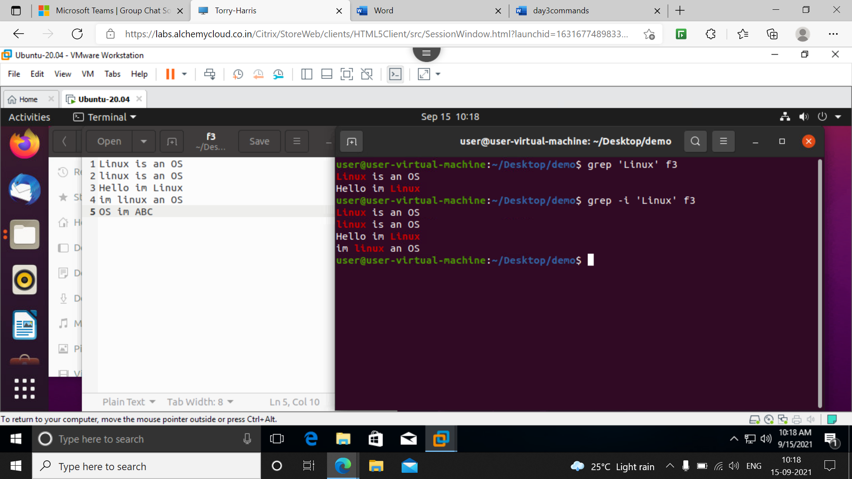

**4] grey -c ‘linux’ f3**

It will give the count of linux word at start of line not in full file (only at start of line or sentences) in below example we have 2 as count mean only two lines start with linux word

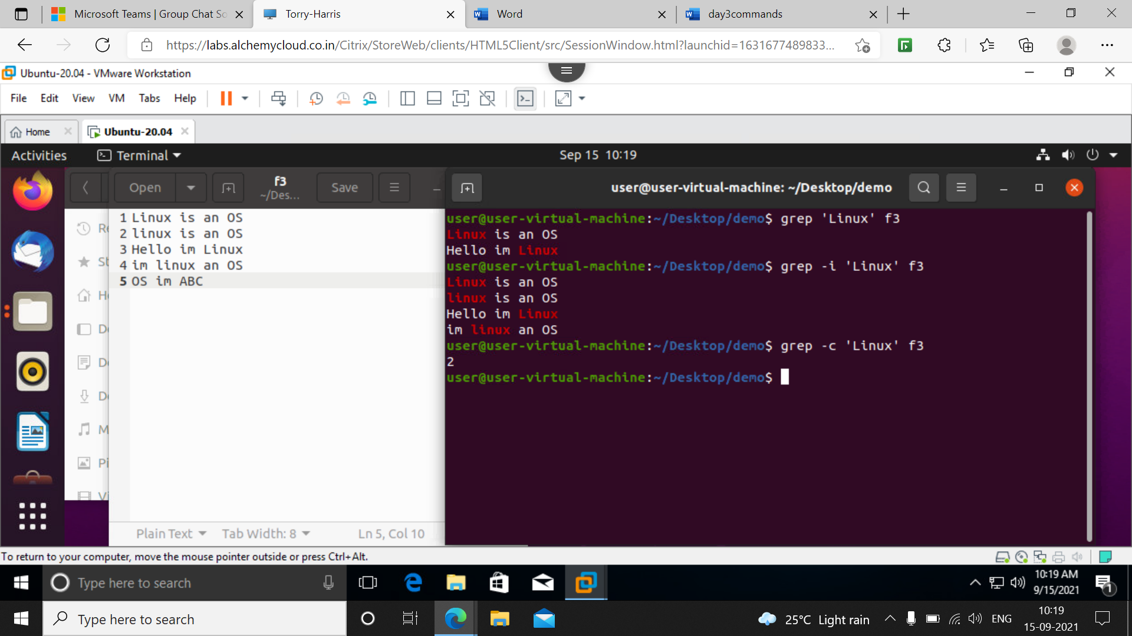

**5] grep –c -I ‘linux’ f3**

It gives total count of word linux in file’

**6] grep –l ‘linux’ \***

It gives in which folder the word linux lies in the above screenshot in f3 file we have word and folder1 and 2 are directories it shows

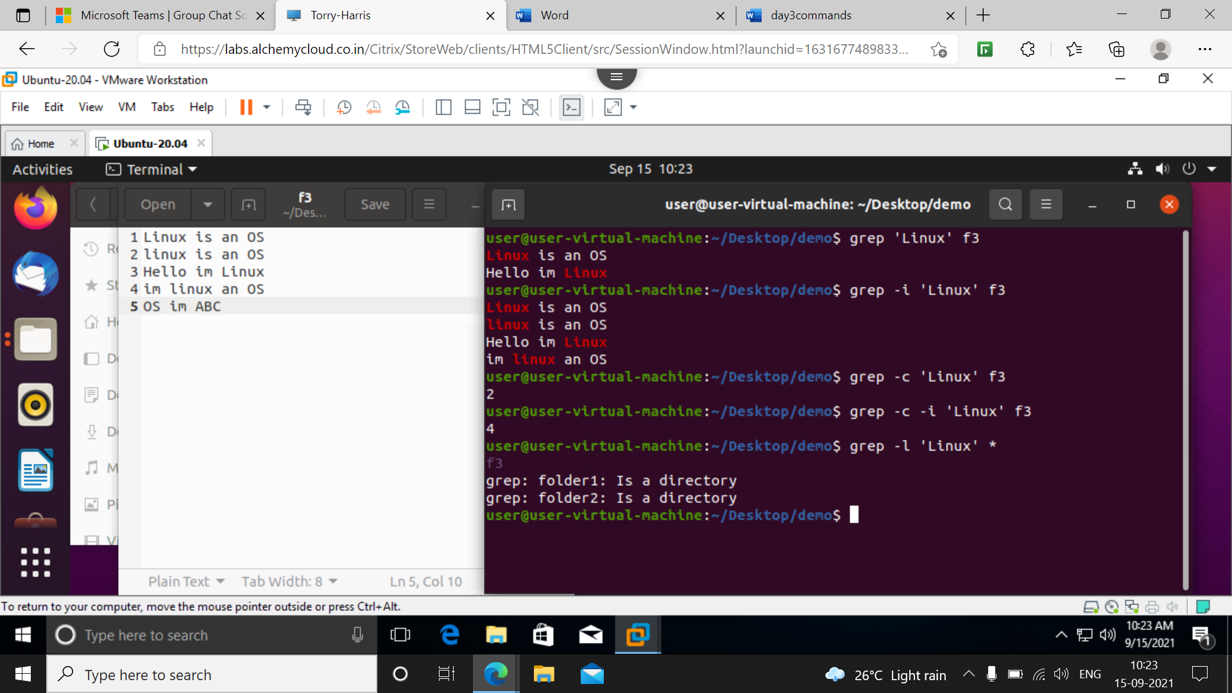

**7] grep –w ‘Linux’ f3 :** this command finds the full fletched word Linux in the below screenshot we have word in two lines as displayed

**8] grep –iw ‘Linux’ f3** : this command displays the word linux ignoring the case all words linux are dispayed as shown in below screenshot

9] grep –n ‘Linux’ f3 : it will give sl. No. Of the lines containing word Linux.

**10] grep –ni ‘Linux’ f3** : it will give sl. No. Of the lines containing word Linux. Irrespective of case all lines are displayed containing word linux.

(screenshot for 7,8,9,10)

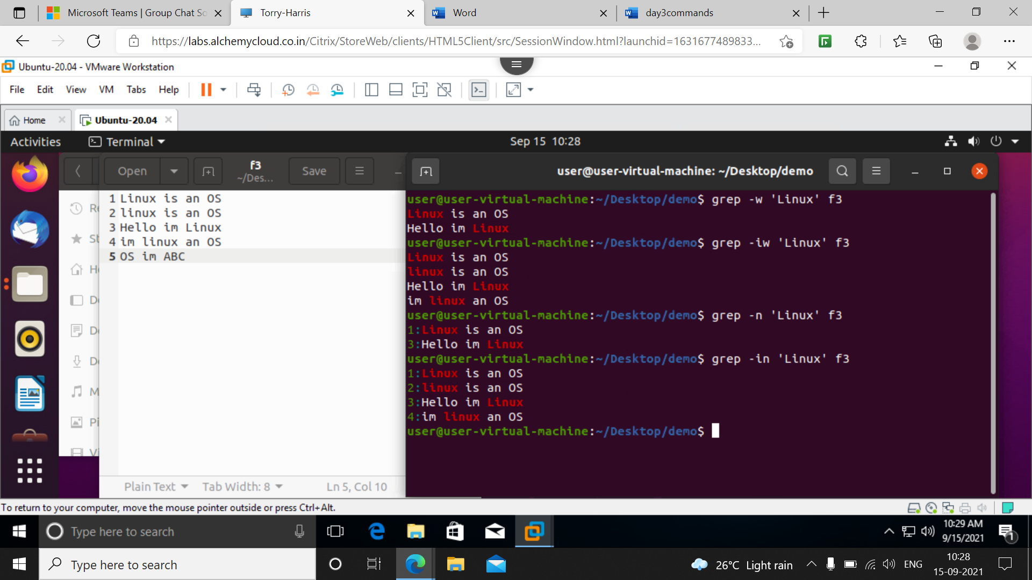

**11] grep –o ‘OS’ f3 :** it will give the exact match of the word OS

**12] grep –io ‘OS’ f3** : it will also give the exact match irrespective of case

**13] grep –w ‘OS’ f3 :** this gives full fletched word match of OS

**14] grep –iwo ‘OS’ f3** : this gives all matches of word os irrespective of cases

(screenshot for 11,12,13,14)

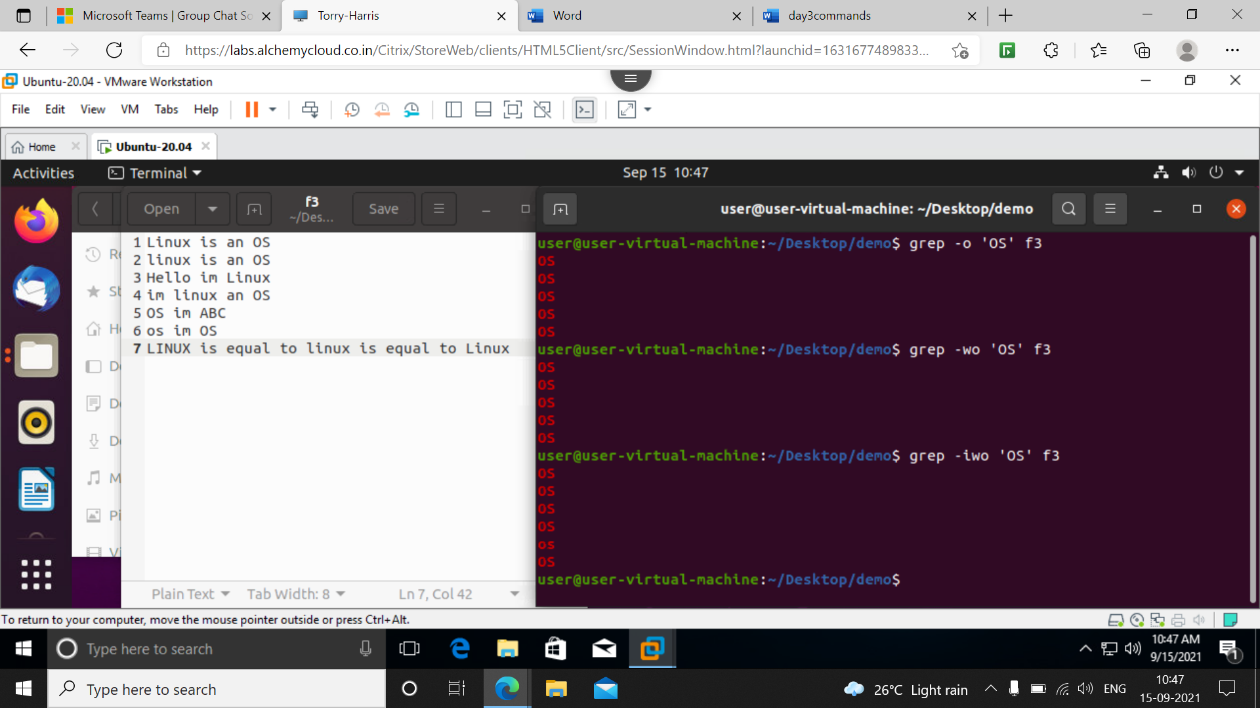

**15] grep –n ‘Linux’ f**3 : it will give line number of word Linux in the file.

**16] grep –n ‘linux’ f3** : it will give line number of word linux in the file.

**17] grep –in ‘Linux’ f3** : it will give line number of word Linux in the file irrespective of cases.

**18 ] grep –iown ‘Linux’ f3** : it will give line number of word Linux in the file all words are included here .

(screenshot for 15,16,17,18)

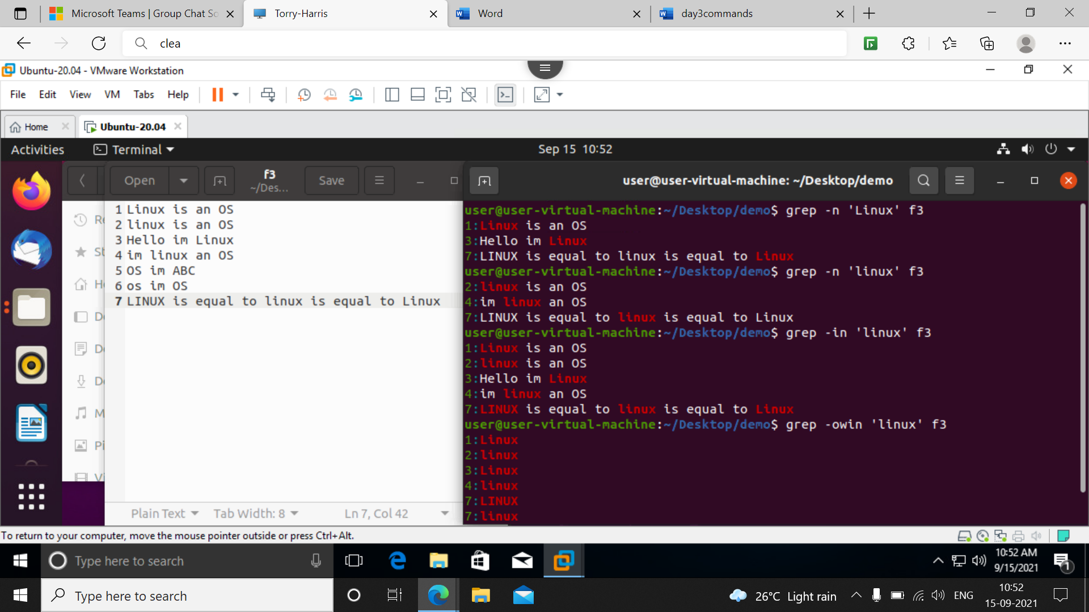

**19] grep -I –v ‘linux’ f3** : it will eliminate the word linux from our file and display other lines

**20] grep -In –v ‘linux’ f3** : it will eliminate the word linux from our file and display the sl no of the line also as shown in screenshot

(screenshot for 19,20)

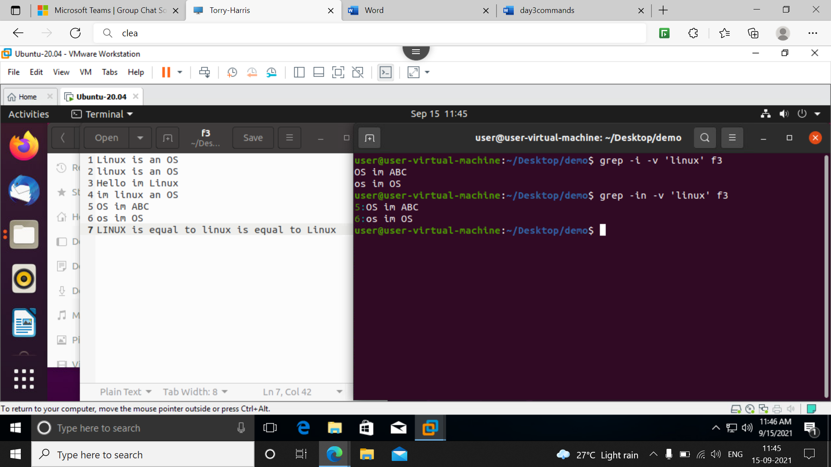

(^ start with and $ for end with)

**21] grep -I ‘^linux’ f3** : this command gives the line which start with linux word

Use of ^ indicates start with following word

**22] grep -I ‘linux$’ f3** : this command indicates the line ends with word linux

Use of $ after the respective word shows it ends with display it

(for 21,22)

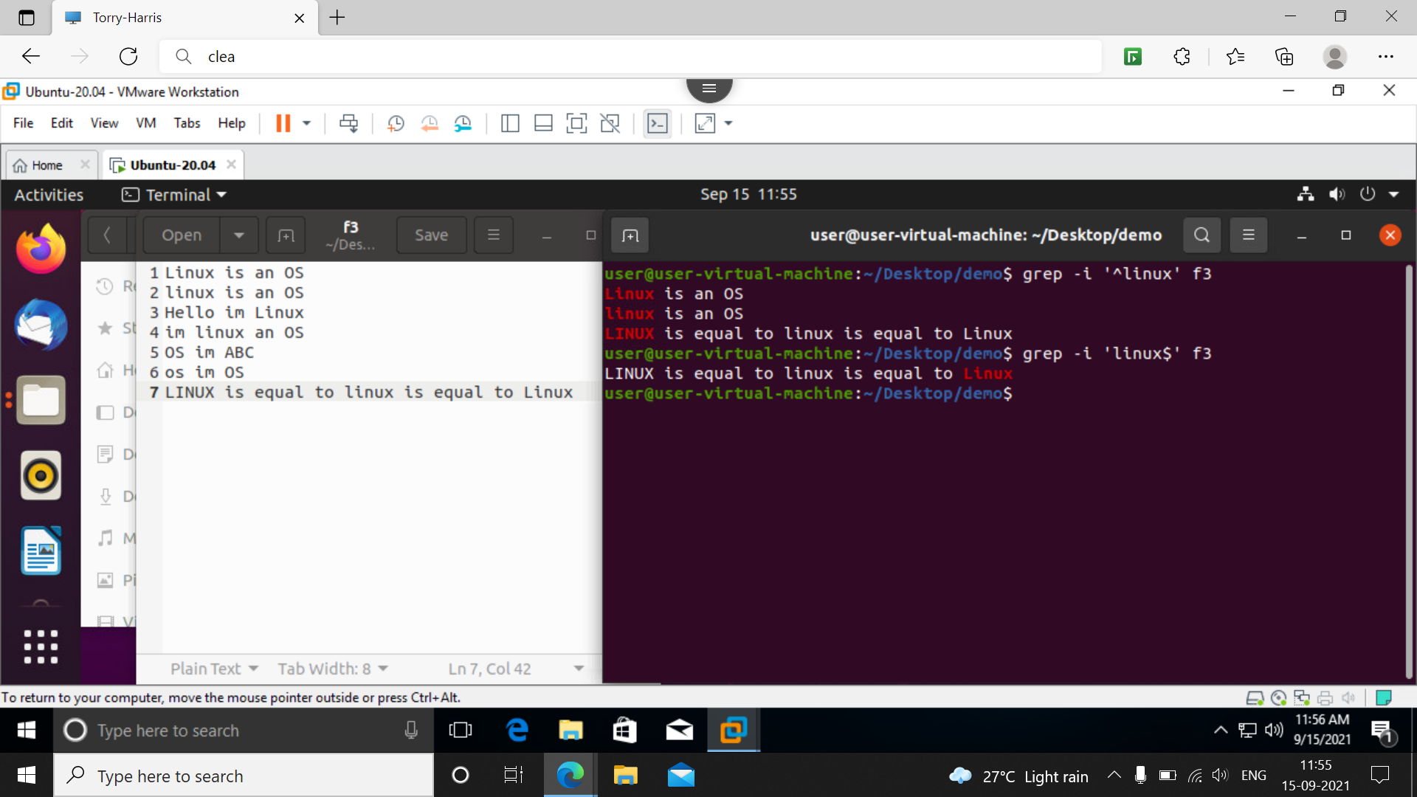

**23] grep –niE ‘^os,*os$’**

The above command tells that the sentence should start with os and ends with os in the below screenshot it is shown

And another example to start with h and end with p and any character can be present in between.

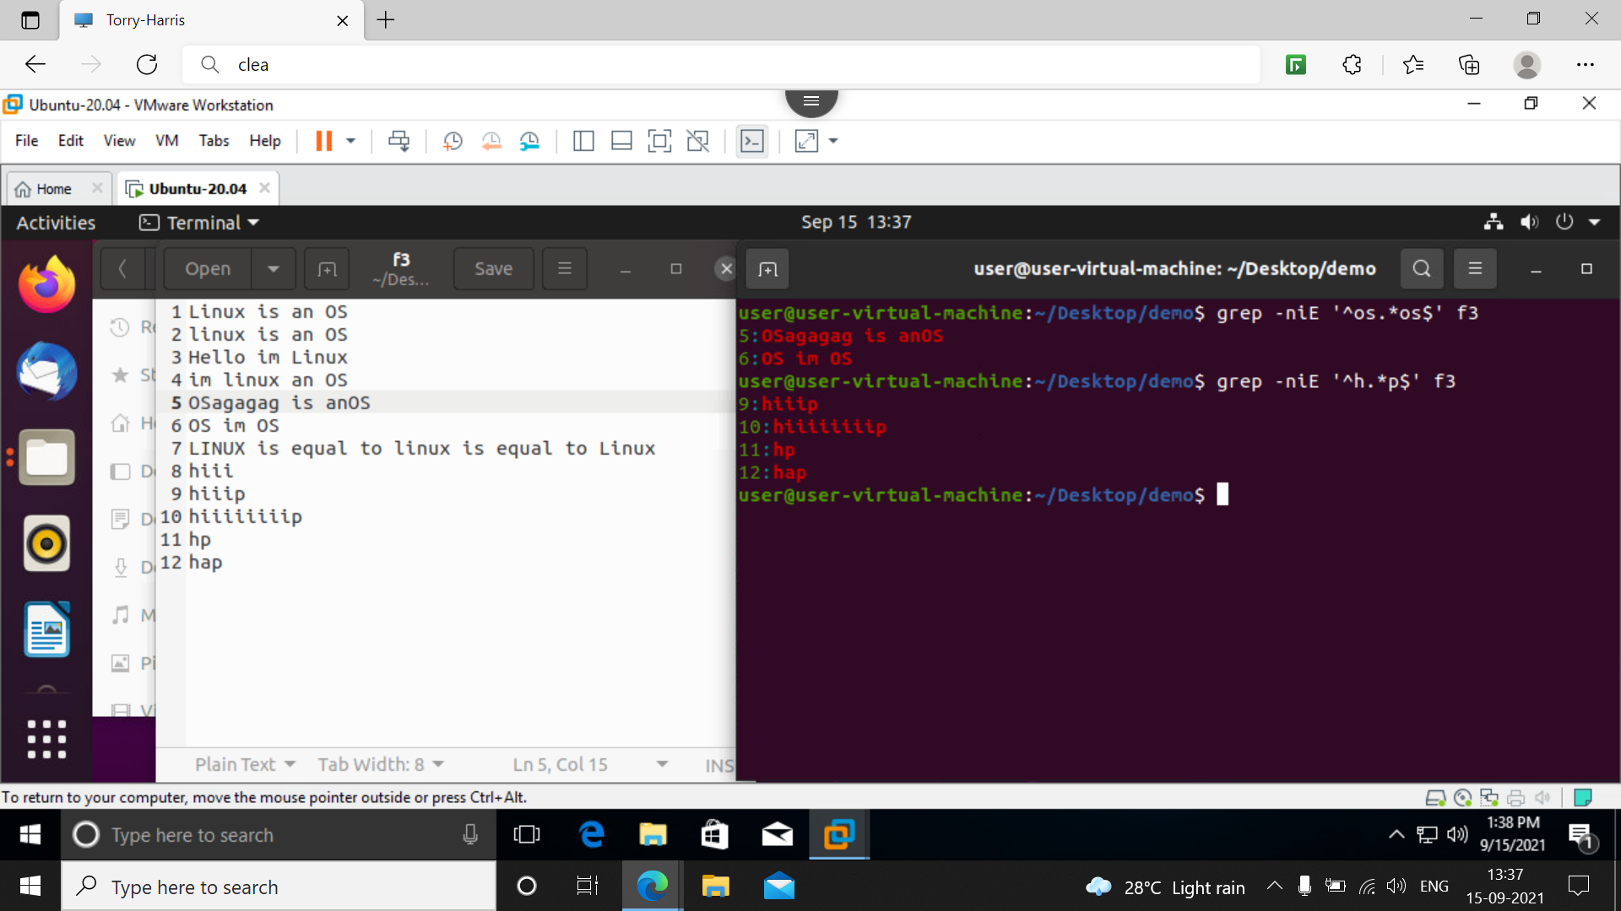

**24] grep –niE ‘^h[I].*p$’ f3**

This command tells the sentence should start with h and should have ‘i’ as second letter and so on and ends with p as shown in example

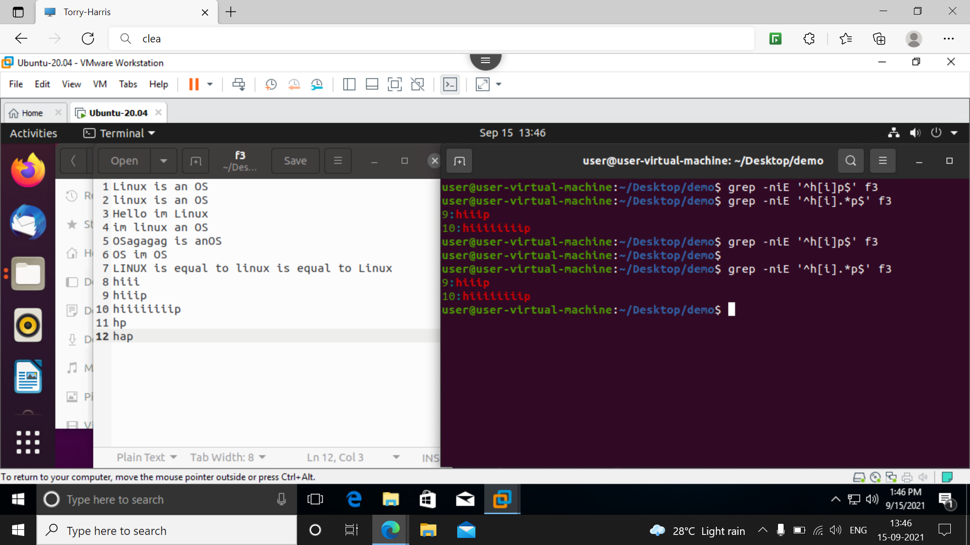

**25] grep –niE ‘^h[I]+p$’ f3**

This command shows the data should start with h and contains ‘i’ as 2nd 3rd and so on and print data as shown

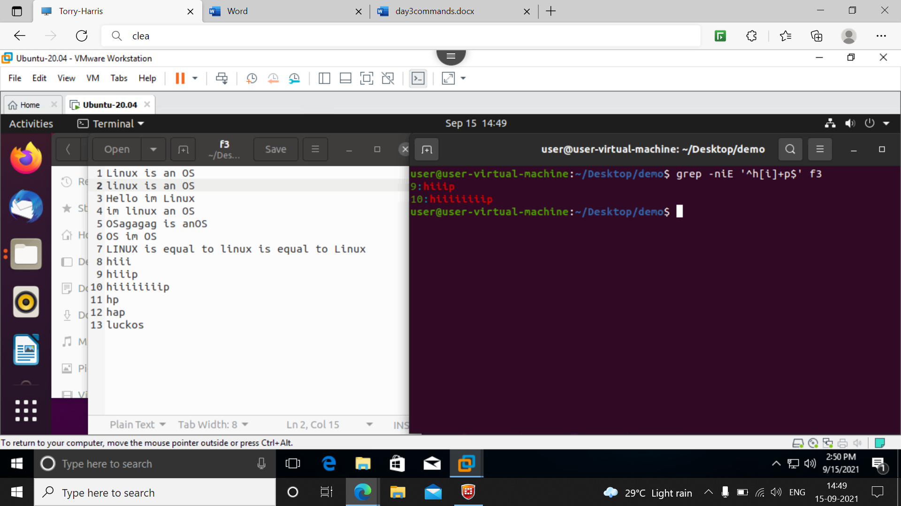

26] **grep –niE ‘^h[I]*p$’ f3**

This command shows in f3 file the data which start with ‘h’ and ends with ‘p’ to be displayed

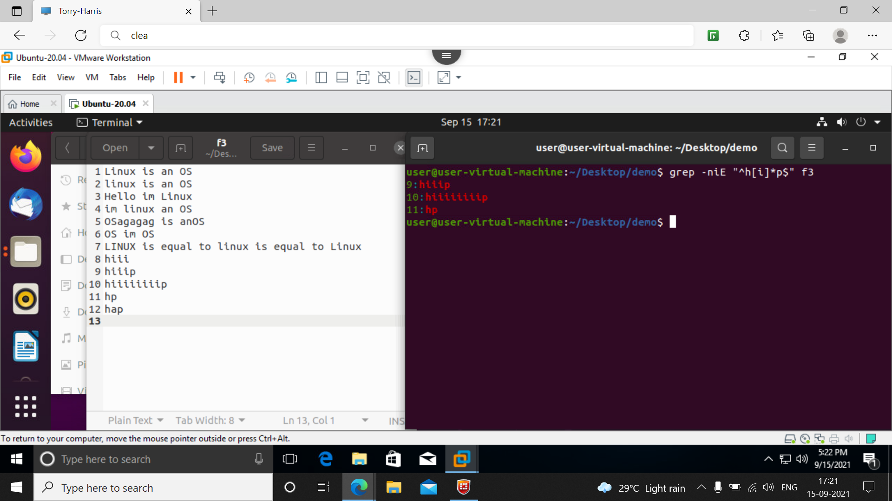

27] **grep –niE ‘^h[^I]*p$’ f3**

This command gives in f3 file it should start with ‘h’ and end with ‘p’ it should not contain ‘i’ so the op wll be displayed as shown below

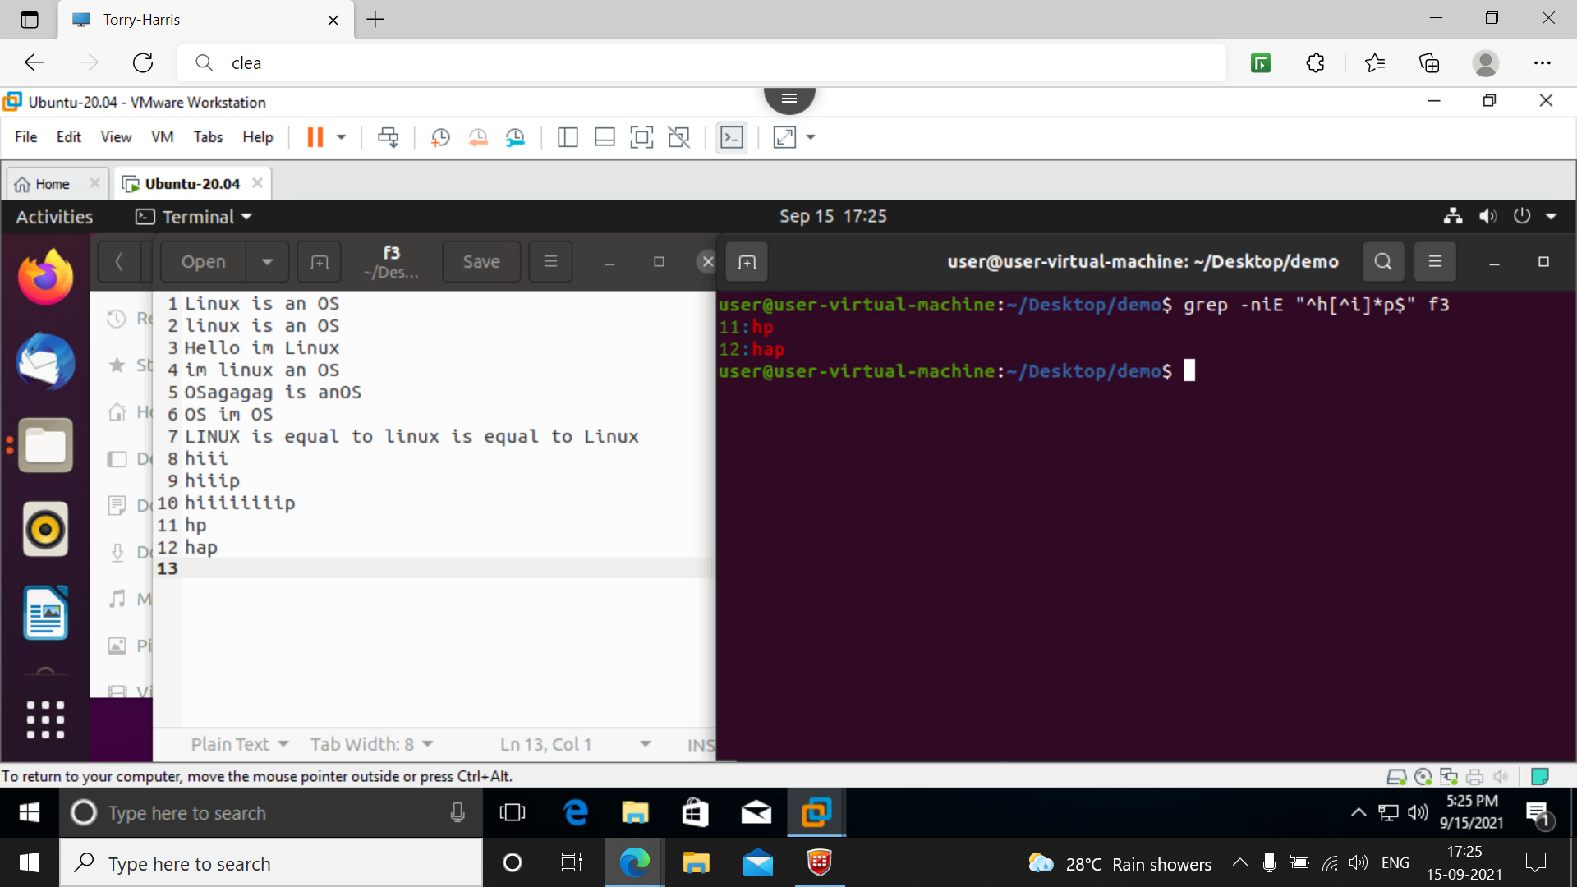

28] **grep –niE ‘’^[a-l].*” f3**

This command tells in f3 it should start with [a-l] in bw a to l and can end with any character the op dispalyed

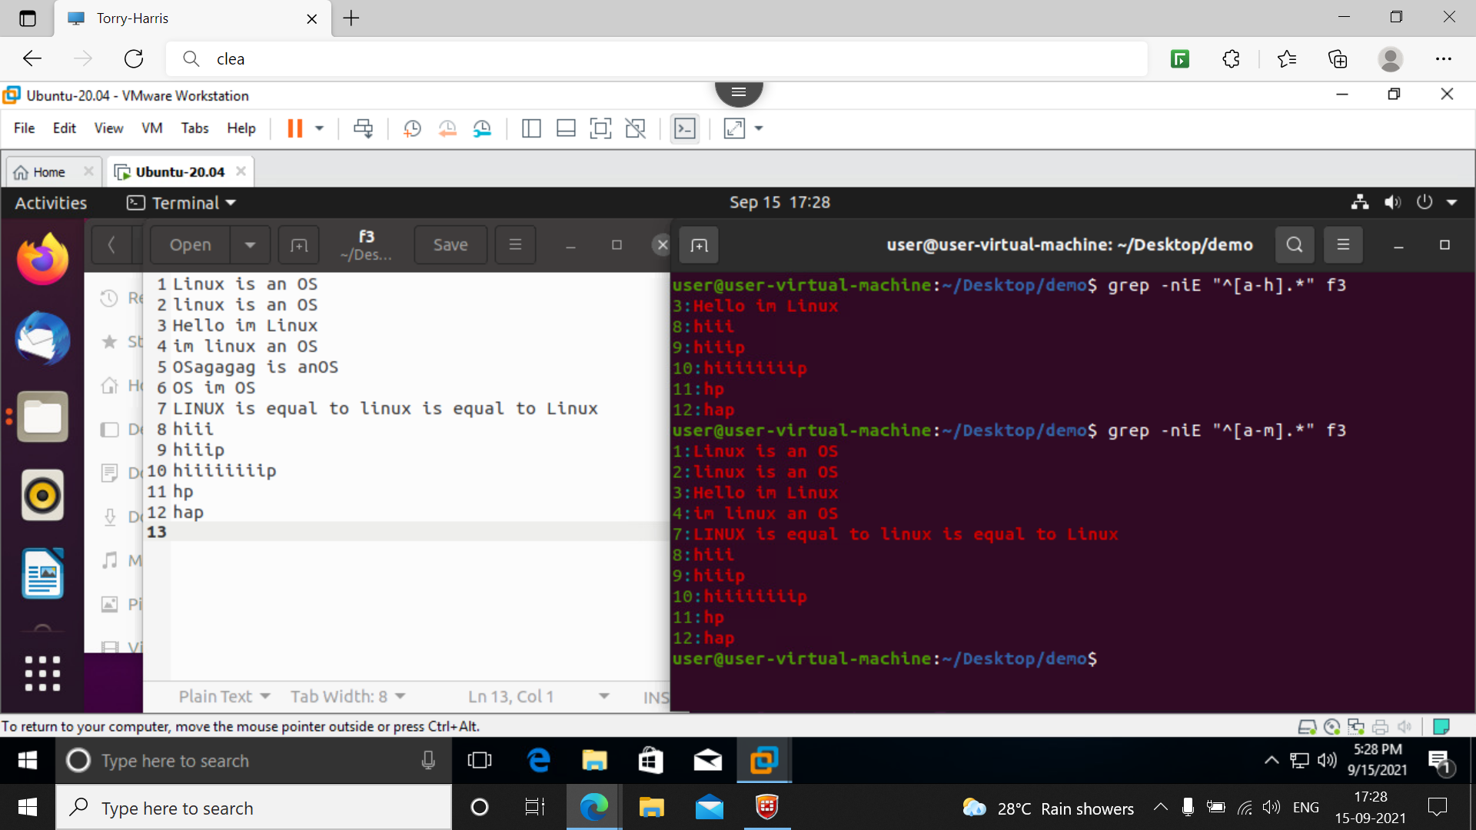

**30] cut –c 1 f3:**

It shows the 1st column of f3 file should be displayed.

In the exmaple I displayed 1st and 3rd column

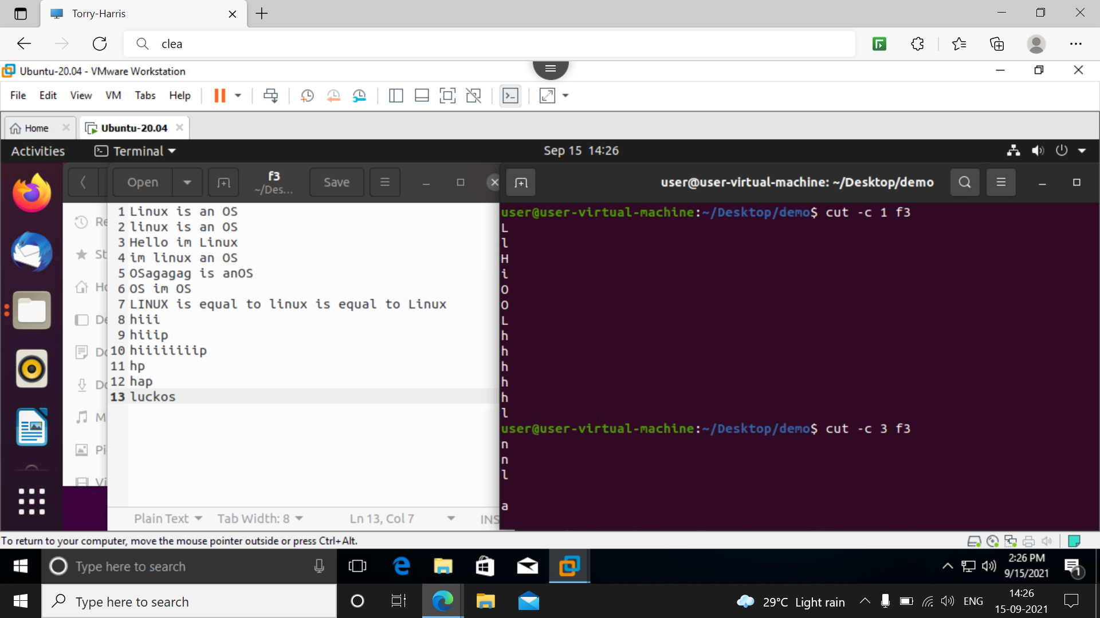

**31] cut –c 1-4 f3**

**32 cut –c –4 f3**

The both command stands same it shows data to be printed from 1st to 4th column of the file

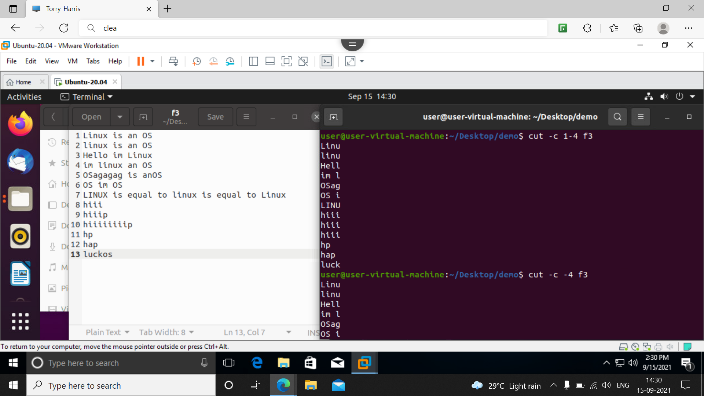

33] cut –c 3- f3

This command gives to print the data from column 3 and forward if it has no limit I.e till last word

If any limit given it should be done till there like cut –c 3-7 f3 mean from 3 to 7 column

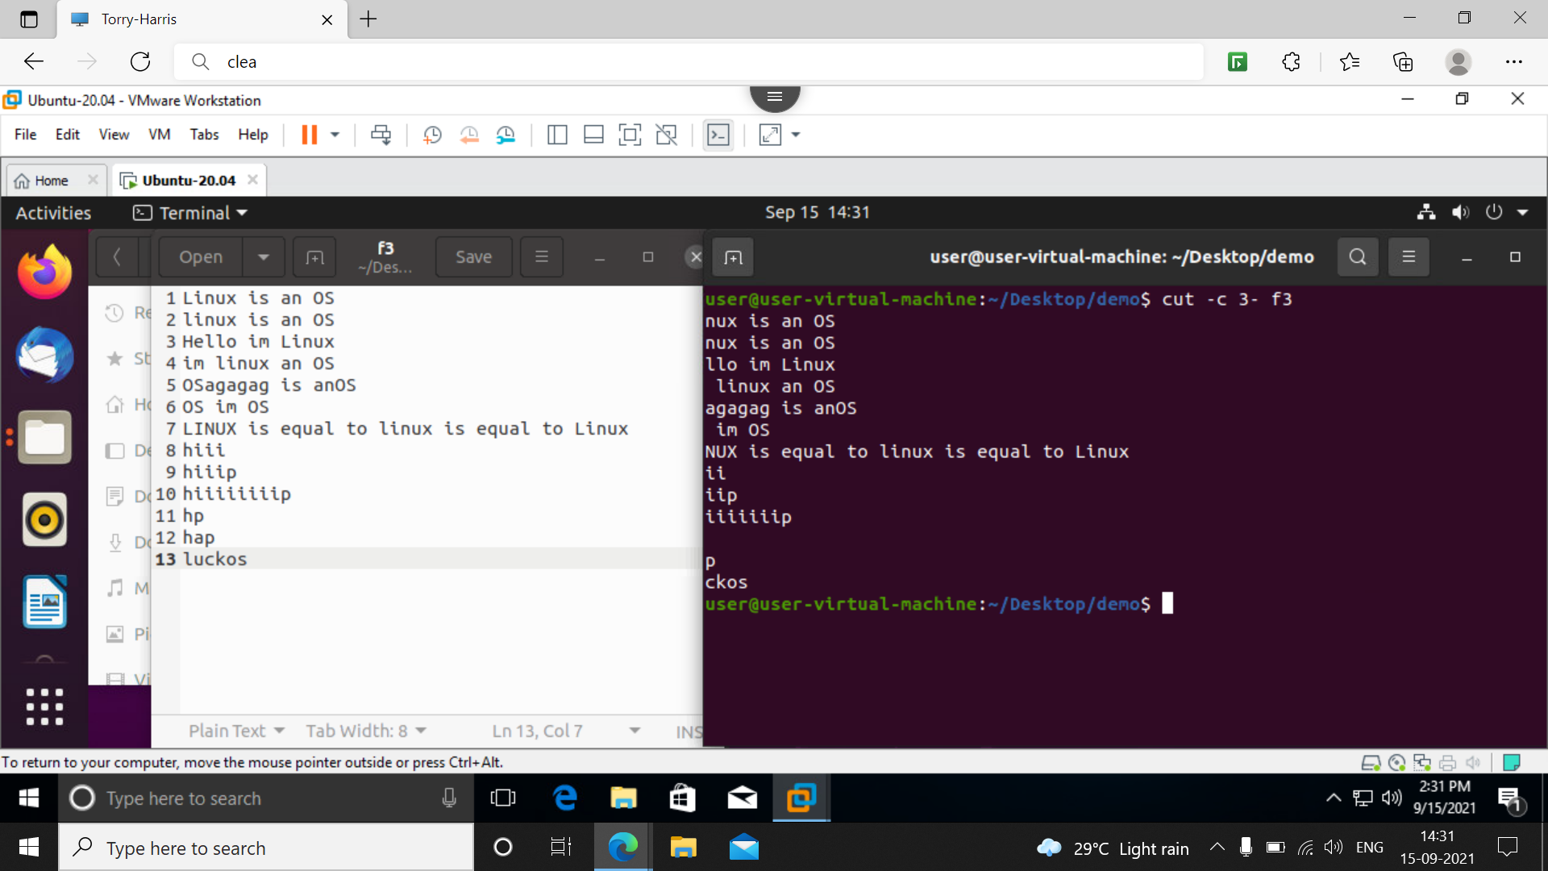

**34] cut –c 1,4-7 f3**

This command tells to print data of 1st column and then from 4 to 7 as shown below

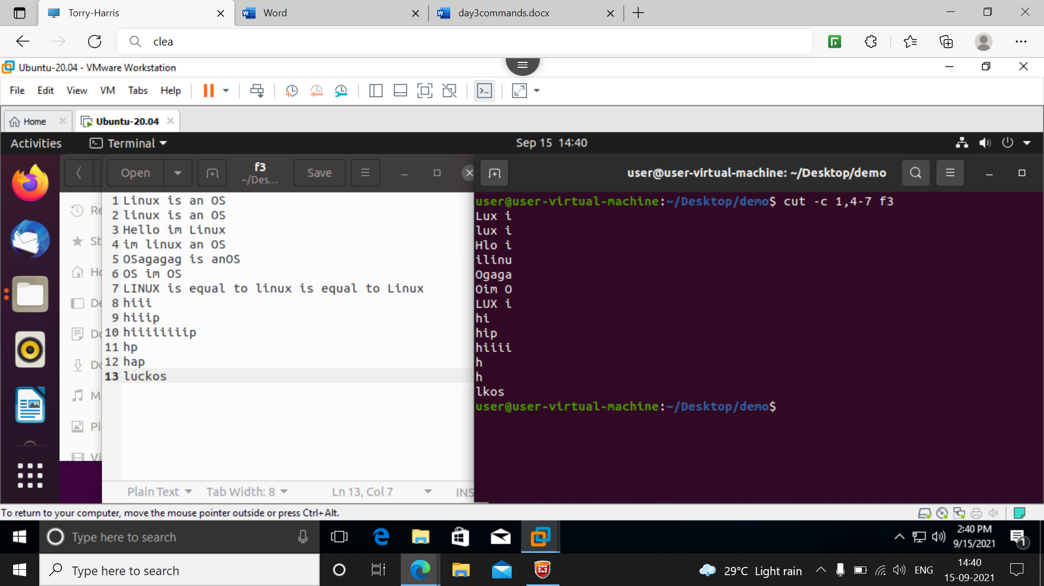

**35] cut –b 1,4-7 f3**

This also does the same but it will calculate in terms of bytes

**36] cut -d ‘ ‘ -f 1 f3**

This command ‘d’ stands for delimeter and in f3 till the first space data should be printed

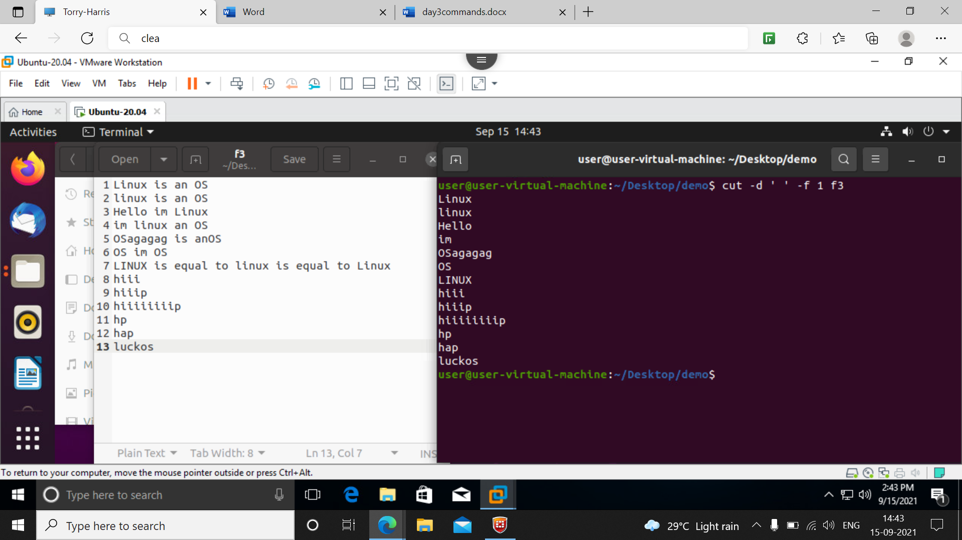

**37] cut -d ‘i‘ -f 1 f3**

This command the data to be displyed till the first ‘i’ character is counted after that it wll stop

In foll example its shown execution stopped after I

The delimeter may be any character or special character

